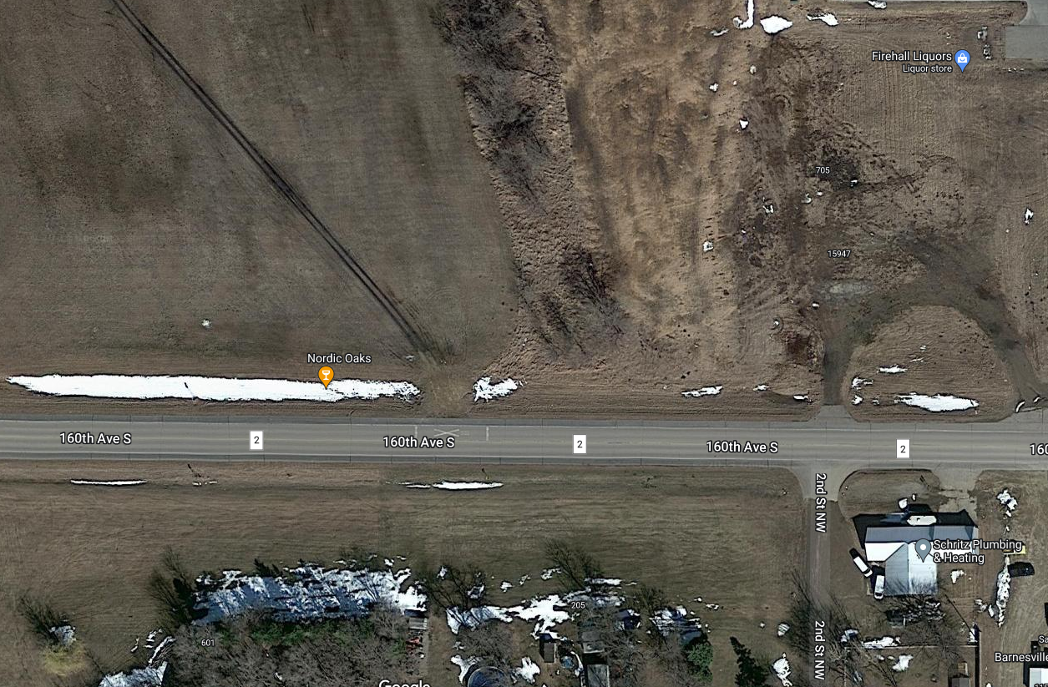
CURRENT FIELD ACCESS – REQUEST IS TO CHANGE THIS TO A COMMERCIAL PROPERTY ENTRANCE

